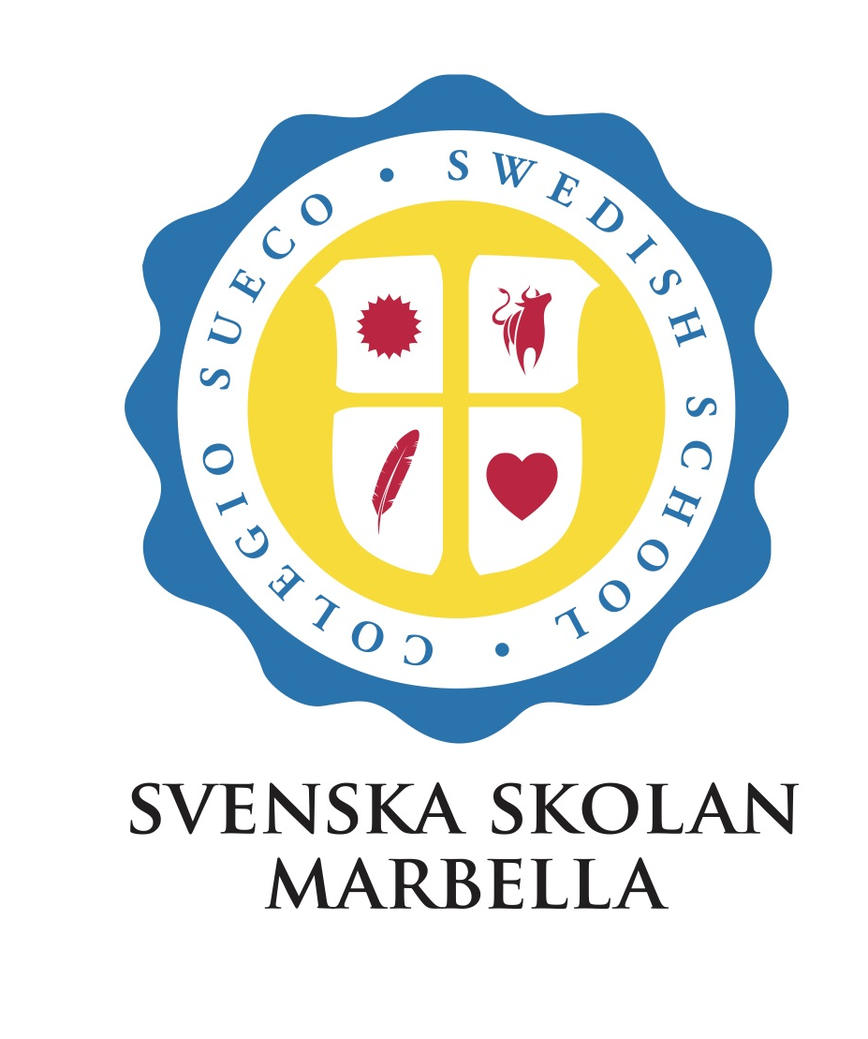

Academic Calendar 2024-2025

INTERNATIONAL CURRICULUM

| **First Semester 2024 (August to January)** | |
| --- | --- |
| Monday 2nd September | Autumn term starts |
| Monday 21st October | Deadline for progress reports to LS |
| Friday 25th October | Progress reports to Parents |
| Monday 28th October - Friday 1st november | Autumn half term/ no school |
| Tuesday 5th November | Parents meetings |
| Friday 6th December | National Holiday Día de la Constitución/ school closed |
| Monday 9th December | National holiday / Inmaculada Concepción |
| Monday 16th December | Deadline autumn reports to LS |
| Friday 20th December | Autumn term report to Parents |
| Friday 20th December | Autumn term ends |
| 21st December - 6th January | Christmas Break |
| Tuesday 7th January | All Students and Staff back to school |
| Wednesday 8th January | Spring term starts |
| Friday 31st January | Svenska system last day of Autumn term |
| **Second Semester 2025 (February -June)** | |
| Monday 3rd February | Start Svenka’s Summer term |
| Monday 17th February | Deadline for progress reports spring term to LS |
| Friday 21st February | Progress reports Spring term to parents |
| Monday 24th - Friday 28th February | Semana Blanca Holidays |
| Tuesday 4th March | Parents meetings |
| Monday 7th April | Deadline Spring term reports to LS |
| Friday 11th April | Spring term Reports to parents |
| Friday 11th April | Spring term ends |
| Monday 14th - Friday 18th April | Easter Holidays / No school |
| Monday 21st April | Summer term starts |
| Thursday 1st May | National holiday school closed |
| Wednesday 4th June | Svenska - SofIa Distans finishes |
| Wednesday 11th June | San Bernabé / School closed |
| Friday 13th June | Svenska - Hermods and Sofia Distans finish school |
| Monday 16th June | Deadline for end of year report LS |
| Thursday 19th June | End of Year report to Parents |
| Thursday 19th June | Summer term ends - Last day of academic year |